Monet Art Garden Tea Party
By Sharon Jeffus
Copyright 2019
Elements of art: line, color, texture, radial lines, form
Master artists: Claude Monet, Ambrosius Bosschaert the Elder
What you will need: You will need a table with a bright colored tablecloth. You will need colored pencils and markers. You will need tissue paper in different values of the color blue, pink, white, green, red and yellow. You will need gemstones, feathers, different kinds of paper, etc. You will need white cardstock paper and posterboard. You will need white craft glue and small brushes for putting your glue on the small posterboard. If you have buttons to glue on as the center of flowers, that would be terrific. You can also precut sandpaper into small squares for the center of the flowers.
You will need tea cups and delightful sweets on places in the center of your table
Art Projects: Waterlily tissue paper painting,

Everyone loves the idea of a garden tea party! Our subject for this party is the wonderful Impressionist Monet. Monet loved gardens and flowers. He was a leader in the style of Impressionism. Impressionism is characterized by relatively small, thin, yet visible brush strokes, and the emphasis on accurate depiction of light in its changing qualities. He is most famous for his pictures of water lilies. Have you ever seen water lilies?
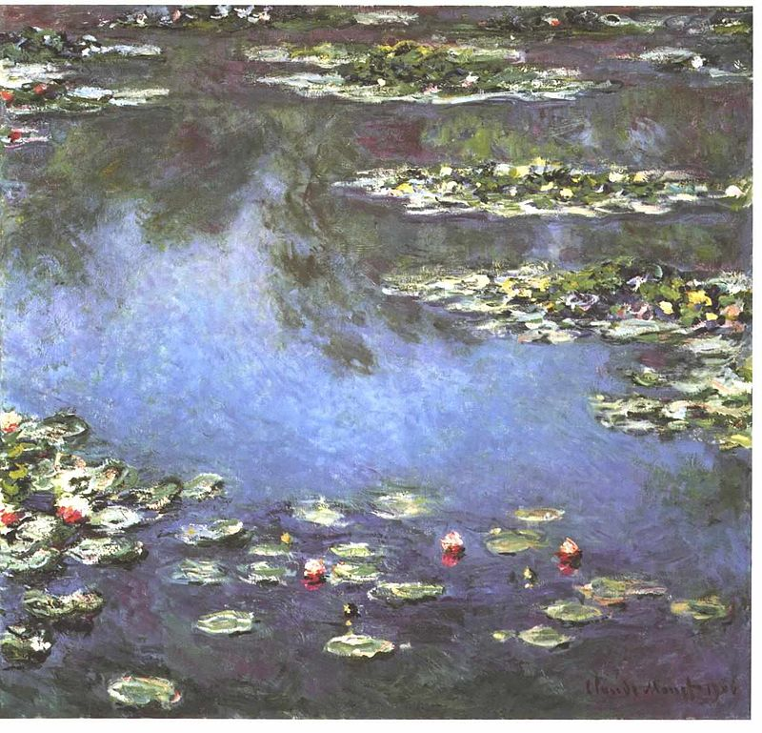
Our first tea party project will be to create a tissue paper painting of Water Lilies.

- Cut or tear long strips different shades of blue paper for the water. You can add white strips as well. You can glue this on your poster board paper.
- tear shorter strips of purple and green tissue paper
- pour a good amount of white glue into a container and add a bit of water to thin it out, mixing it well with the end of a paintbrush
- 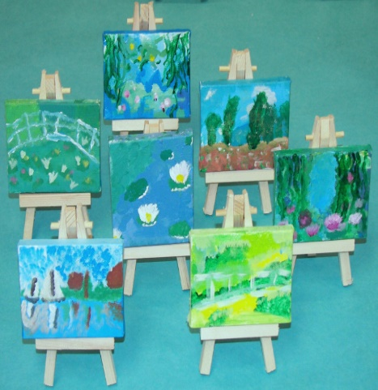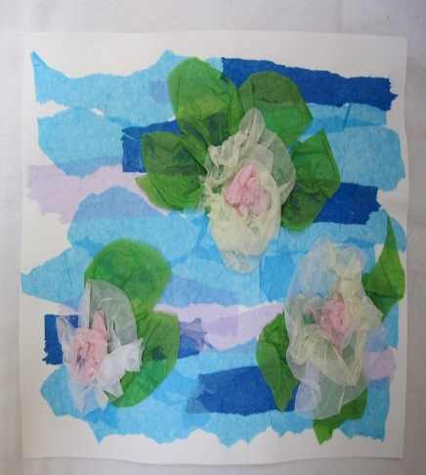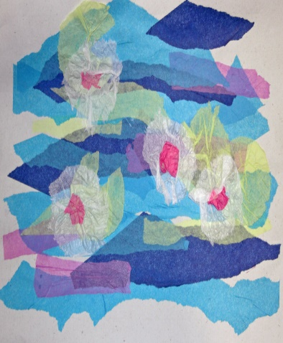
Although Monet did many beautiful pictures of gardens and flowers that we will look at he also did wonderful cariactures of people turning them into insects. You will need a piece of cardstock paper and pencils. You can color it in with markers or colored pencils. Here is a picture on the left Monet did, turning the person into a butterfly. Can you do a picture of an insect you could see in a garden that has human personality?

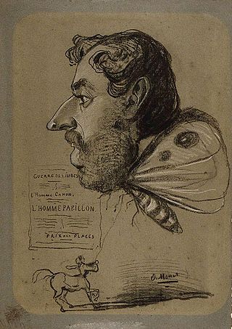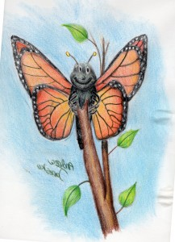
Monet had many beautiful pictures of flowers.
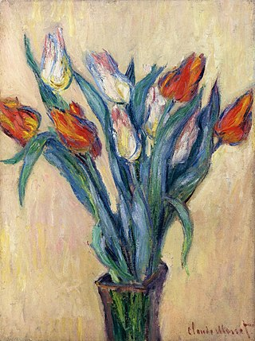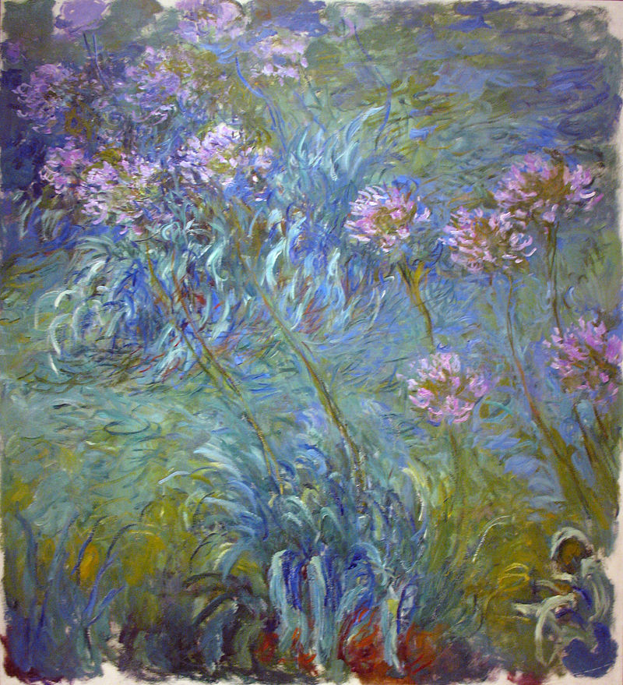
The further you stand away from the pictures, the more realistic they look. That is a trait of Impressionism. Colors are true to life. Tissue paper flowers are easy and fun.